SIMATS ENGINEERING

(SAVEETHA SCHOOL OF ENGINEERING)
Department of Computer Science and Engineering

ASSESSMENT TOOL 2 – EXPERIMENTATION

Course Code: | ITA03 | Course Title: | Mobile Computing
CO Assessed: | CO2 | Assessment: | Assessment Tool 2 – Experimentation
Weightage: | 30 % of CIA | Total Marks: | 100 Marks
CO2 Statement: | Compare mobile communication technologies, including multiple access techniques and network evolution, based on performance and applications.
Student Name: | A.Manoj Reddy | Reg. No.: | 192311171
Section / Batch: | BE CSE/2023 | Date: | 26-10-2026
Code of Conduct
I A.Manoj Reddy (Name / Reg. No) certify that this submission is my original work and that I have adhered to the guidelines specified for this assessment. I understand that any violation of academic integrity rules will result in disciplinary action.
Signature of the Student: A.Manoj Reddy
Instructions
- This test contains FIVE questions.
- Duration: 60 minutes (homework).

Faculty In-charge  Signature: Date: | Course Coordinator  Signature: Date: | Head of Department  Signature: Date:

ANNEXURE A – QUESTIONS AND SOLUTIONS
Each solution follows the evaluation rubric: A. Design Quality • B. Technical Analysis • C. Correctness of Concepts • D. GitHub Repository & Documentation • E. Creativity and Visualization

Question 1: Figma-Based Mobile IP Communication Workflow Analysis (BL4 – Analyze)

Problem Statement
Design an interactive Figma prototype illustrating the complete workflow of Mobile IP communication when a Mobile Node moves from its Home Network to a Foreign Network, including the HA, FA, CN, CoA, registration process and packet tunneling, and analyse the communication process.
- Design Quality (Figma Design) [20 Marks]
The design is built as four connected Figma frames; the frames are linked with prototype arrows so they can be played in sequence.
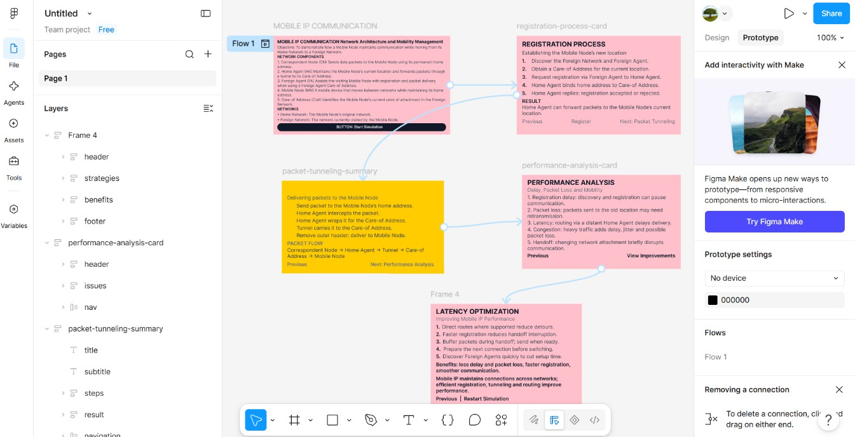
Figure 1: Figma design frames – Mobile IP workflow (Frame 1 to Frame 4)

Complete design board

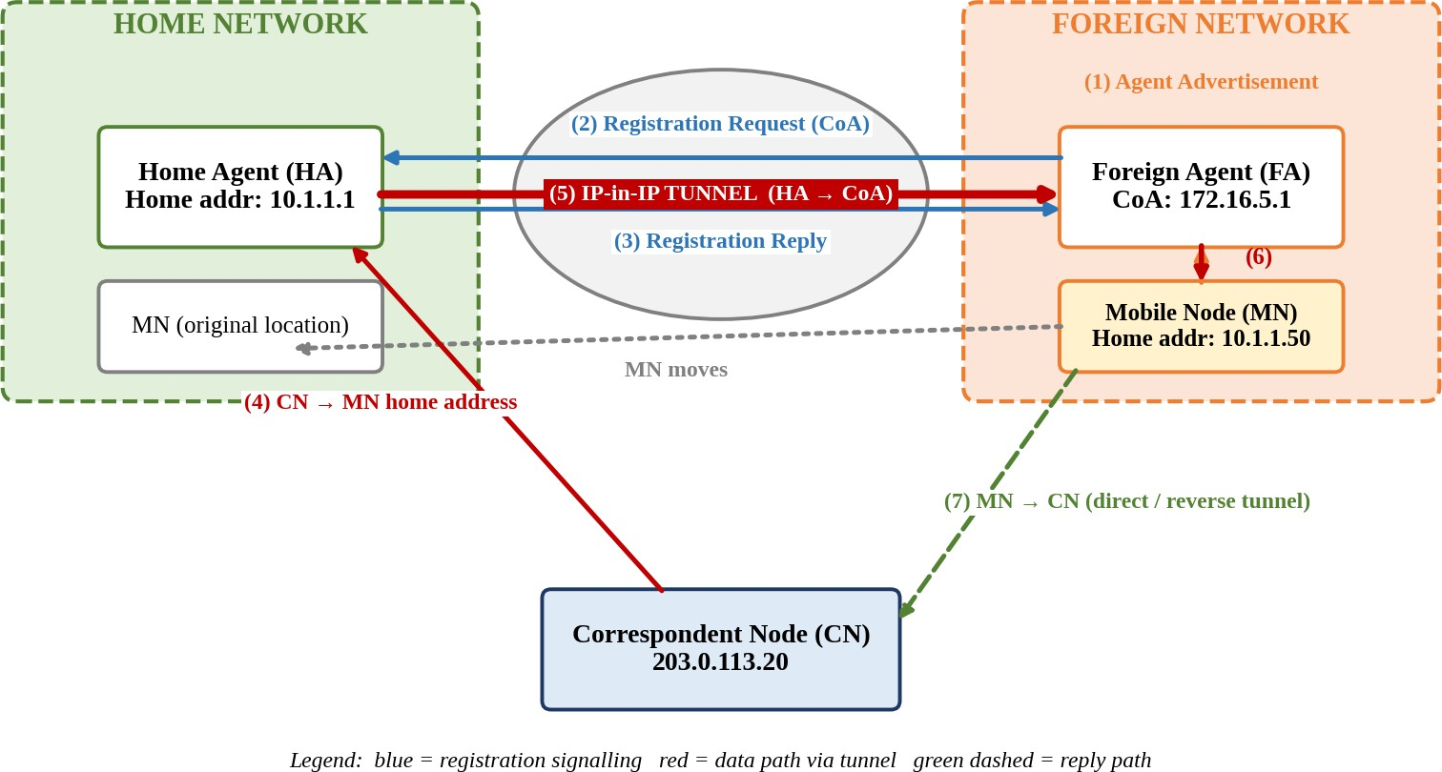
Figure 2: Figma design output – Mobile IP workflow (registration and packet tunneling)

Design description
  - Layout: One flow board with the Home Network (green) on the left, the Foreign Network (orange) on the right, and the Internet and CN in the centre.
  - Flow: Numbered steps (1)–(7) show agent advertisement, registration request and reply, interception, tunneling, delivery and return traffic.
  - Colour coding: Blue = registration signalling, red = tunneled data path, green dashed = return path, grey dotted = node movement.
  - Prototype: Frames per step, linked with Figma prototype arrows (On click → Navigate to) so the sequence can be played from the first to the last step.

Workflow summary
  - Agent discovery: FA advertises; the MN learns it is in a foreign network and obtains a CoA.
  - Registration: MN → FA → HA request binds the home address to the CoA; the HA replies.
  - Interception and tunneling: HA intercepts packets for the home address and encapsulates them to the CoA.
  - Delivery: FA decapsulates and delivers to the MN; the MN replies directly or through a reverse tunnel.

- Technical Analysis [30 Marks]

Purpose of each network component

Component | Purpose
Mobile Node (MN) | Device that changes its point of attachment while keeping a permanent home IP address.
Home Agent (HA) | Home-network router that keeps the binding table, intercepts packets for the MN and tunnels them to the CoA.
Foreign Agent (FA) | Visited-network router that advertises, relays registration, decapsulates tunneled packets and delivers them to the MN.
Correspondent Node (CN) | Peer host that addresses packets only to the MN's home address.
Care-of Address (CoA) | Temporary address identifying the MN's current location.
Registration Process | Signalling that creates or refreshes the home-address-to-CoA binding.
Packet Tunneling | Encapsulation that carries packets from the HA to the CoA without altering the original datagram.

Points where packet delay or packet loss may occur

Point | Cause | Effect
Movement / handoff | MN detaches from the old link before registration completes. | Packets sent to the old location are dropped.
Registration round trip | Request and reply cross the Internet to the HA and back. | Handoff latency grows with HA distance.
HA processing | Binding lookup and encapsulation for every packet. | Queuing delay; HA becomes a bottleneck.
Triangular routing | CN → HA → FA → MN is longer than the direct path. | Higher delay and extra bandwidth.
Tunnel overhead | Extra 20-byte outer IP header per packet. | Lower payload efficiency; possible fragmentation.
Binding expiry | Registration lifetime ends or a reply is lost. | Traffic lost until re-registration.

Effect of node mobility on communication performance
  - Frequent movement causes repeated registrations, raising signalling overhead and packets lost per handoff.
  - TCP throughput falls because losses are read as congestion and the window shrinks.
  - Latency rises with distance from the HA because every packet takes the home-network detour.
  - At high speed the registration time can exceed the time spent in a cell, making the connection unstable.

Possible improvements to reduce latency
  - Route optimisation – CN caches the binding and sends directly to the CoA, removing triangular routing.
  - Hierarchical Mobile IP – A local mobility anchor handles intra-domain moves so the distant HA is not contacted.
  - Fast handover – Pre-register with the next FA and buffer packets at the old FA during the switch.
  - Co-located CoA / nearer HA – Use a co-located CoA and regional HAs closer to users.
- Correctness of Mobile Networking Concepts [20 Marks]

Concept | Correct technical statement
Mobile IP | IETF standard (RFC 5944 for IPv4, RFC 6275 for IPv6) that lets a node keep one home address while changing network.
Agent discovery | Uses ICMP Router Discovery extended with mobility agent advertisements.
Registration | Request and reply messages are sent over UDP (port 434) with authentication extensions.
Tunneling | IP-in-IP encapsulation (RFC 2003); the FA or MN removes the outer header.
CoA types | FA CoA (FA address) or co-located CoA (address obtained by the MN, e.g. via DHCP).
Triangular routing | Forward path goes through the HA while the return path is direct; it is solved by route optimisation or reverse tunneling.

GitHub Repository Organization & Documentation [15 Marks]
Repository structure

Folder / File | Contents
/design/ | mobile-ip-workflow.fig (editable Figma file)
/exports/ | PNG and PDF exports of every frame and the full prototype
/docs/ | analysis-report.pdf (components, delay points, improvements)
/assets/ | icons, colour palette, fonts
README.md | Project overview, how to open the prototype, screenshots

README.md contents
  - Title, objective and problem statement.
  - Link to the Figma prototype and instructions to play it.
  - Exported workflow image and component description.
  - Analysis summary and references (RFC 5944, RFC 6275).

- Creativity and Visualization [15 Marks]
  - Colour-coded network zones and message types for quick reading.
  - Animated packet movement between frames using Figma Smart Animate.
  - Clickable component cards showing the purpose of the HA, FA, CN and CoA.
  - Step numbers and a legend so the workflow can be followed without extra explanation.

Question 2: Comparative Network Architecture Design Using Figma (BL4 – Analyze)

Problem Statement
Create a comparative architectural diagram showing a Cellular Wireless Network and a Mobile Ad Hoc Network (MANET) operating in the same smart city environment, and analyse both architectures.
- Design Quality (Figma Design) [20 Marks]
The design is built as four connected Figma frames; the frames are linked with prototype arrows so they can be played in sequence.
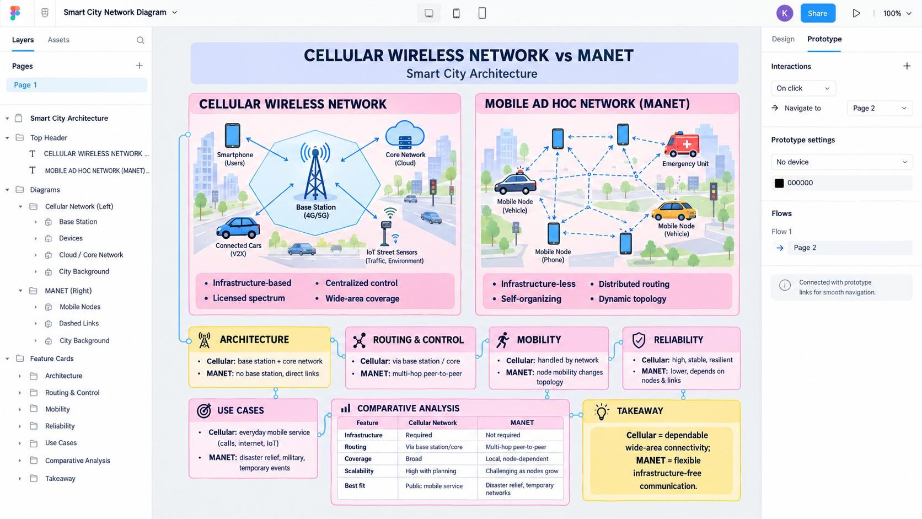
Figure 3: Figma design frames – Cellular Network and MANET comparison (Frame 1 to Frame 4)

Complete design board
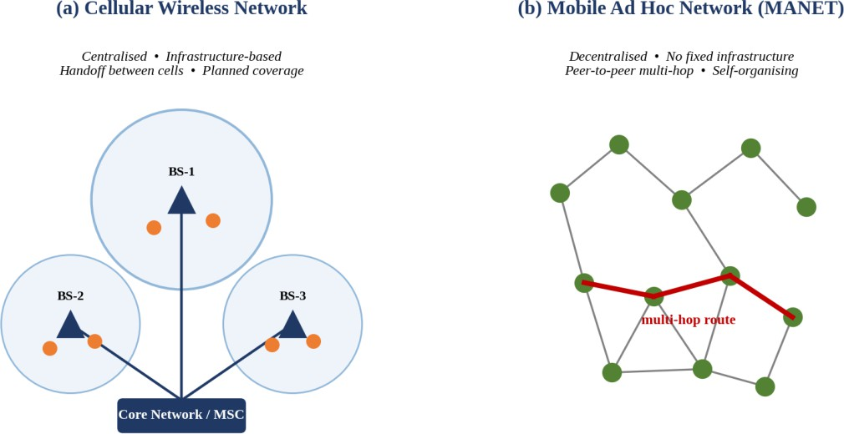
Figure 4: Figma design output – Cellular Network and MANET in a smart city

Design description
  - Layout: Two panels with matching scale: cells with base stations and a core network on the left, peer nodes with a multi-hop route on the right.
  - Annotations: Annotation callouts under each panel list the advantages and limitations.
  - Colour coding: Blue for cellular elements, green for ad hoc nodes, red for the active route.
- Technical Analysis [30 Marks]

Parameter | Cellular Wireless Network | Mobile Ad Hoc Network (MANET)
Infrastructure dependency | Fully dependent on base stations, backhaul and core network. | No fixed infrastructure; nodes act as hosts and routers.
Routing mechanism | Centralised routing and mobility management through the core network. | Distributed routing by AODV, DSR, DSDV or OLSR.
Scalability | Scales by adding cells and reusing spectrum. | Degrades as node count grows due to control overhead and contention.
Fault tolerance | A base-station or core failure affects a cell; mitigated by redundancy. | No single point of failure; routes are rebuilt around failed nodes.
Mobility support | Seamless handoff between cells at vehicular speeds. | Supported, but topology change causes route breaks.
Suitable applications | Voice, broadband, IoT metering, city-wide coverage. | Disaster recovery, V2V messaging, temporary events, military.

Advantages and limitations

 | Advantages | Limitations
Cellular | Planned coverage, high reliability and QoS, managed security, seamless handoff. | High deployment and spectrum cost, infrastructure dependence, congestion in crowded areas.
MANET | Rapid deployment, low cost, self-healing, works without infrastructure. | Limited bandwidth and battery, security threats, poor scalability, unstable routes.

Conclusion: In a smart city, cellular networks should carry the backbone services while MANETs complement them for emergency response, vehicle-to-vehicle messaging and areas without coverage.
- Correctness of Mobile Networking Concepts [20 Marks]

Concept | Correct technical statement
Cellular concept | Coverage is divided into cells; frequency reuse increases capacity.
Handoff | Call or session is transferred between cells without interruption (hard or soft handoff).

Concept | Correct technical statement
Mobility management | Location databases (HLR/VLR in GSM, MME/HSS in LTE) track the user's current cell.
MANET | Self-configuring network of mobile nodes with multi-hop wireless links and no central controller.
Medium access | MANETs commonly use IEEE 802.11 CSMA/CA, which suffers from hidden and exposed terminal problems.

GitHub Repository Organization & Documentation [15 Marks]
Repository structure

Folder / File | Contents
/design/ | cellular-vs-manet.fig / .drawio (editable files)
/screenshots/ | Exported PNG of both architectures and annotations
/report/ | comparison-report.pdf
/assets/ | icons and shapes used
README.md | Overview, comparison summary, usage

README.md contents
  - Objective and scenario description.
  - Screenshots with the comparison table.
  - Advantages and limitations summary.
  - Tools used and how to open the design files.
- Creativity and Visualization [15 Marks]
  - Same smart-city scenario shown in both architectures for a fair side-by-side comparison.
  - Icons for base stations, vehicles and sensors, with the multi-hop route highlighted.
  - Callout annotations placed directly on the diagram instead of in a separate legend.

Question 3: Routing Protocol Visualization and Analysis (BL4 – Analyze)

Problem Statement
Develop a visualisation of one Proactive routing protocol (DSDV) and one Reactive routing protocol (AODV) in a mobile wireless network and analyse route discovery, maintenance, overhead, delay and performance under high mobility.
- Design Quality (Figma / Visualization) [20 Marks]
The design is built as four connected Figma frames; the frames are linked with prototype arrows so they can be played in sequence.
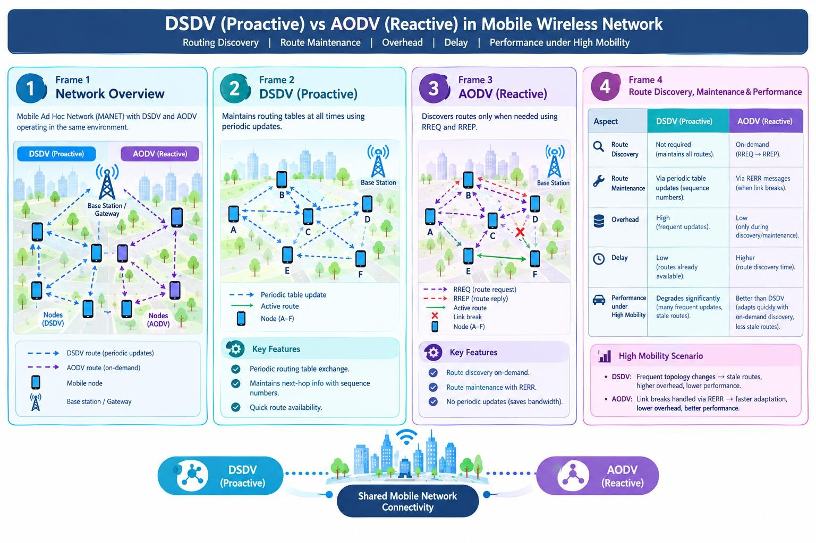
Figure 5: Figma design frames – DSDV and AODV routing visualization (Frame 1 to Frame 4)

Complete design board
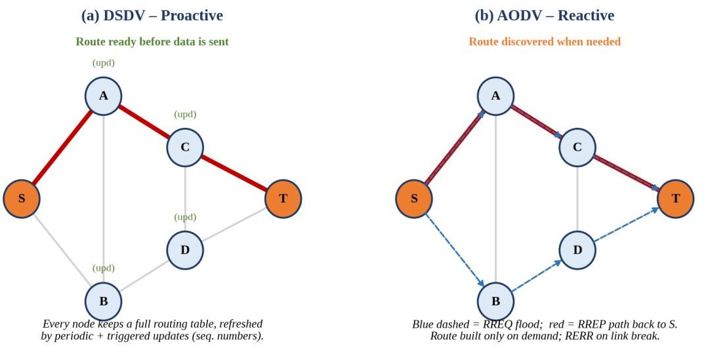

Figure 6: Figma design output – DSDV (proactive) and AODV (reactive) on the same topology

Design description
  - Layout: Same six-node topology used for both protocols so that behaviour is directly comparable.
  - Colour coding: Red = selected route, blue dashed = RREQ flood, green markers = periodic table updates.
  - Interaction: Frames step through route discovery, data transfer and a link break to show maintenance.
- Technical Analysis [30 Marks]
DSDV: every node keeps a table of next hop, metric and sequence number for all destinations, exchanged periodically and on change, so routes always exist.
AODV: a source broadcasts a Route Request (RREQ); the destination or a node with a fresh route replies with a Route Reply (RREP) along the reverse path; link breaks are reported with Route Error (RERR).

Aspect | DSDV (Proactive) | AODV (Reactive)
Route discovery | None needed; routes pre-computed. | RREQ flood and unicast RREP when needed.
Route maintenance | Periodic and triggered updates with sequence numbers. | Hello messages and RERR; re-discovery on demand.
Routing overhead | High and constant even without traffic; grows with size. | Low when traffic is light; bursts of flooding.
Delay to establish communication | Minimal, route exists. | One route-discovery round trip.
Performance under high mobility | Tables go stale; heavy updates and loss. | Better, as only active routes are repaired.

Comparative summary by mobility condition

Mobility condition | Better protocol | Reason
Low mobility, dense traffic | DSDV | Stable topology keeps update overhead modest; no start-up delay.
Moderate mobility | AODV | Overhead is spent only on routes in use.
High mobility | AODV | DSDV updates cannot keep pace; AODV repairs only active paths.
Delay-critical, small network | DSDV | Routes are always ready.

- Correctness of Mobile Networking Concepts [20 Marks]

Concept | Correct technical statement
DSDV | Table-driven protocol based on the Bellman–Ford distance-vector algorithm; destination sequence numbers prevent routing loops.
AODV | On-demand distance-vector protocol defined in RFC 3561; uses RREQ, RREP, RERR and destination sequence numbers.
Proactive vs reactive | Proactive protocols maintain routes continuously; reactive protocols build routes only when data is to be sent.
Expanding ring search | AODV limits RREQ flooding by gradually increasing the TTL.

GitHub Repository Organization & Documentation [15 Marks]
Repository structure

Folder / File | Contents
/src/ | visualisation source code or Figma/Mermaid files
/screenshots/ | DSDV and AODV step-by-step images
/analysis/ | analysis-report.pdf with comparison
README.md | How to run or open the visualisation

README.md contents
  - Objective and protocols covered.
  - Instructions to run the visualisation.
  - Screenshots of each stage.
  - Analysis summary and references (RFC 3561, Perkins & Bhagwat 1994).

- Creativity and Visualization [15 Marks]
  - Side-by-side panels on one topology, with a step slider for the protocol stages.
  - Animated RREQ flooding and a highlighted RREP return path.
  - A simulated link failure showing how each protocol reacts.

Question 4: Mobile IP Application Design for Smart Healthcare (BL4 – Analyze)

Problem Statement
Design a Smart Healthcare Mobile IP system in Figma that keeps doctors, ambulances, hospitals and patients connected while moving across different wireless networks, and analyse its operation.
- Design Quality (Figma Design) [20 Marks]
The design is built as four connected Figma frames; the frames are linked with prototype arrows so they can be played in sequence.
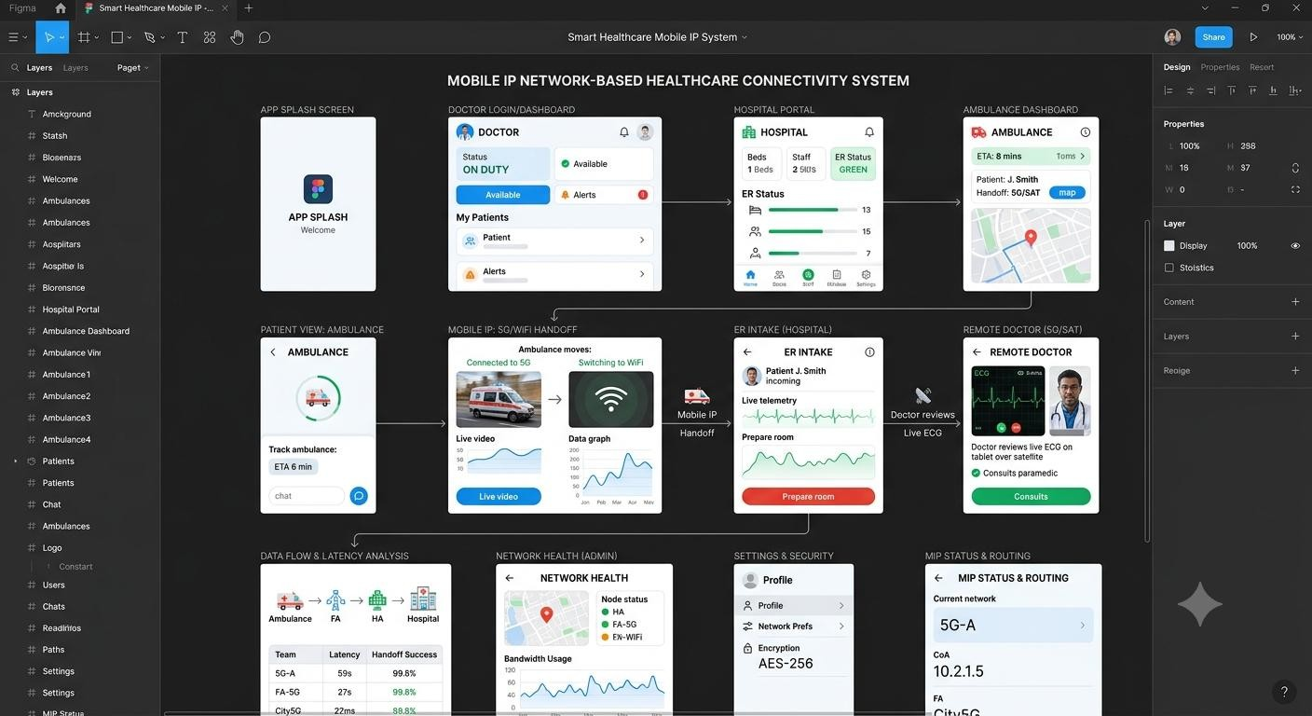
Figure 7: Figma design frames – Smart Healthcare mobile app screens (Frame 1 to Frame 4)

Complete design board
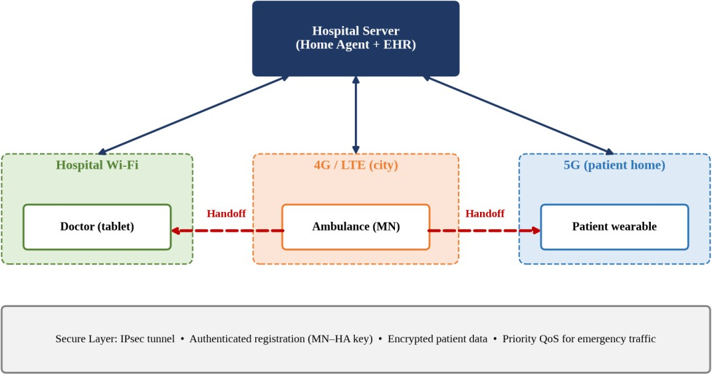

Figure 8: Figma design output – Smart Healthcare Mobile IP architecture with handoff

Prototype screen navigation

Screen | Name | Mobility scenario demonstrated
1 | Login & Authentication | Mutual authentication with the hospital Home Agent.
2 | Dashboard | Live network status, current CoA and connection quality.
3 | Ambulance Tracking | Ambulance moves from 4G to hospital Wi-Fi; vitals keep streaming.
4 | Doctor Consultation | Doctor roams between wards with a live video session.
5 | Patient Monitoring | Wearable moves from home Wi-Fi to 5G, reachable at its home address.
6 | Handoff & Alerts | Handoff events, packet loss and security warnings.

- Technical Analysis [30 Marks]

How Mobile IP maintains uninterrupted communication
Each device keeps a permanent home address. When it moves, it registers a new care-of address with the Home Agent (hospital server), which tunnels packets to the current location, so sessions continue across Wi-Fi, 4G and 5G.

Challenges during handoff between networks
    - Handoff delay causes brief loss of vital-sign packets and interrupts live video.
    - Different bandwidth, latency and IP versions affect QoS.
    - Triangular routing adds delay when the ambulance is far from the Home Agent.
    - Frequent re-registration drains the wearable's battery.

Security vulnerabilities during mobility

Vulnerability | Risk | Countermeasure
Spoofed registration | Attacker redirects patient traffic to a false CoA. | Authenticated registration with MN–HA key.
Replay attack | Old registrations reused to hijack a session. | Timestamps or nonces.
Eavesdropping on tunnel | Patient data exposed on public networks. | IPsec / TLS encryption.
Rogue Foreign Agent | Fake FA captures or alters packets. | FA authentication and certificates.
DoS on Home Agent | Flooded registrations exhaust the HA. | Rate limiting and redundant HAs.

Design improvements to increase reliability
    - Redundant Home Agents with failover and regional agents.
    - Fast handover with buffering, and multi-homing (Wi-Fi and cellular together) for the ambulance.
    - Route optimisation and priority QoS marking for emergency traffic.
    - Local mobility anchors to reduce registration frequency.
- Correctness of Mobile Networking Concepts [20 Marks]

Concept | Correct technical statement
Mobile IP in healthcare | Permanent home address for each device gives a stable identity for records and monitoring systems.
Vertical handoff | Handoff between different technologies (Wi-Fi ↔ 4G ↔ 5G), more complex than horizontal handoff.
Mobile IP security | Registration is authenticated; data confidentiality is provided by IPsec (RFC 4301).
Route optimisation (MIPv6) | Return routability procedure lets the CN send directly to the CoA, avoiding the HA detour.
Patient data protection | Health data must be encrypted in transit and access-controlled according to applicable privacy regulations.

GitHub Repository Organization & Documentation [15 Marks]
Repository structure

Folder / File | Contents
/design/ | smart-healthcare.fig (editable prototype)
/exports/ | PDF and PNG of all screens, exported prototype
/docs/ | analysis and design documentation

Folder / File | Contents
README.md | Scenarios, navigation guide, screenshots

README.md contents
- Objective and users (doctor, ambulance, hospital, patient).
- Prototype link and navigation guide.
- Mobility scenarios and screenshots.
- Security and reliability analysis summary.
- Creativity and Visualization [15 Marks]
- Real-world scenario flow: ambulance trip → hospital arrival → doctor consultation.
- Live network indicator showing the current network and CoA during handoff.
- Red emergency alerts and a clear colour system for each network type.

Question 5: Wireless Network Decision Dashboard Using GitHub Project (BL4 – Analyze)

Problem Statement
Create a dashboard that helps network engineers decide whether a scenario should use Mobile IP, Cellular Networks or Ad Hoc Networks, analysing multiple parameters and justifying the recommendation.
- Design Quality (Figma / Programming Tool) [20 Marks]
The design is built as four connected Figma frames; the frames are linked with prototype arrows so they can be played in sequence.
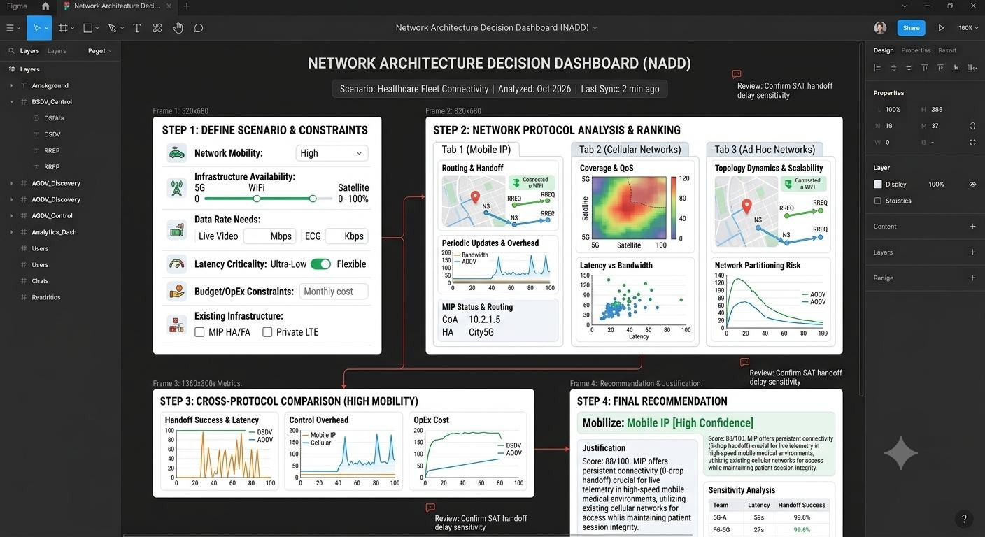
Figure 9: Figma design frames – Wireless Network Decision Dashboard (Frame 1 to Frame 4)

Complete design board
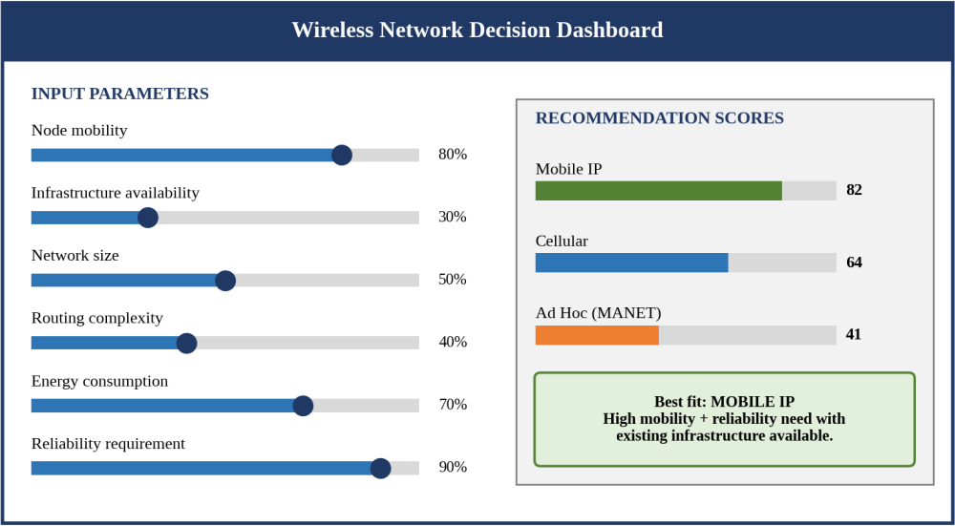
Figure 10: Figma design output – Wireless Network Decision Dashboard

Design description
  - Layout: Inputs on the left (six sliders), results on the right (scores and recommendation card).
  - Colour coding: Navy header, blue controls, green recommendation highlight for clear hierarchy.
- Technical Analysis [30 Marks]

Parameter | Favours Mobile IP | Favours Cellular | Favours Ad Hoc
Node mobility | Medium–high, across IP subnets | Medium–high, wide area | High, local area
Infrastructure availability | IP infrastructure available | Operator coverage available | None or damaged
Network size | Small to large | Large, city scale | Small to medium
Routing complexity | Low (handled by agents) | Low (handled by network) | High (distributed)
Energy consumption | Moderate | Low on device, high on network | High (nodes forward traffic)
Reliability requirement | High, session continuity | High, managed QoS | Moderate, best effort

Recommendation logic
Each parameter is normalised to 0–100 and multiplied by a weight for each technology. The weighted sum gives each score, the highest score is recommended, and the justification lists the parameters that contributed most.

Sample scenario
Inputs: mobility 80 %, infrastructure 30 %, size 50 %, routing complexity 40 %, energy 70 %, reliability 90 %. Result: Mobile IP scores highest because high mobility and a high reliability requirement are met by a permanent address and session continuity. Cellular is a close alternative if coverage improves; Ad Hoc ranks lowest because of the reliability requirement and the energy cost of multi-hop forwarding.
- Correctness of Mobile Networking Concepts [20 Marks]

Concept | Correct technical statement
Mobile IP | Network-layer mobility with a fixed home address; needs IP infrastructure and agents.
Cellular network | Operator-managed, infrastructure-based network with handoff and QoS.
Ad hoc network | Infrastructure-less, multi-hop network where every node routes traffic.

Concept | Correct technical statement
Weighted scoring | A multi-criteria decision method where each parameter's contribution is scaled by its weight.

GitHub Repository Organization & Documentation [15 Marks]
Repository structure

Folder / File | Contents
/src/ or /design/ | dashboard source code (HTML/CSS/JS or React) or Figma project
/screenshots/ | dashboard views for sample scenarios
/docs/ | analysis-report.pdf, scoring rules
README.md | Setup, usage and scoring explanation

README.md contents
  - Objective and features.
  - Setup and run instructions.
  - Parameter definitions and scoring logic.
  - Screenshots and sample results.
- Creativity and Visualization [15 Marks]
  - Live-updating score bars as the sliders move.
  - Plain-language justification generated with every recommendation.
  - Colour-coded recommendation card and preset scenarios (disaster zone, campus, city).

